

Neutral Citation Number: [2025] EWCA Civ 936

Case Nos: CA-2024-002655/002675/002676

IN THE COURT OF APPEAL (CIVIL DIVISION)

ON APPEAL FROM THE HIGH COURT OF JUSTICE, BUSINESS AND PROPERTY COURTS OF ENGLAND AND WALES, INTELLECTUAL PROPERTY LIST (ChD), PATENTS COURT

Mr Justice Mellor

[2024] EWHC 2524 (Pat)

Royal Courts of Justice

Strand, London, WC2A 2LL

Date: 23 July 2025

**Before :**

LORD JUSTICE ARNOLD

LORD JUSTICE SNOWDEN  
and

LORD JUSTICE ZACAROLI

- - - - - - - - - - - - - - - - - - - - -

**Between :**

|  |  |  |
| --- | --- | --- |
|  | 1. **ACCORD HEALTHCARE LIMITED** 2. **ACCORD-UK LIMITED** 3. **SANDOZ AG** 4. **SANDOZ LIMITED** 5. **TEVA PHARMACEUTICAL INDUSTRIES LIMITED** 6. **TEVA UK LIMITED** | Claimants/  Appellants |
|  | **- and -** |  |
|  | **(1) THE REGENTS OF THE UNIVERSITY OF CALIFORNIA**  **(2) ASTELLAS PHARMA EUROPE LIMITED** | Defendants/  Respondents |

- - - - - - - - - - - - - - - - - - - - -

- - - - - - - - - - - - - - - - - - - - -

**Justin Turner KC and Anna Edwards-Stuart KC** (instructed by **Pinsent Masons LLP**) for **Accord and Sandoz**

**Justin Turner KC and Joe Delaney** (instructed by **Pinsent Masons LLP**) for **Teva**

**Andrew Lykiardopoulos KC and Thomas Lunt** (instructed by **Kirkland & Ellis International LLP**) for the **Respondents**

Hearing date : 2 July 2025

- - - - - - - - - - - - - - - - - - - - -

Approved Judgment

This judgment was handed down remotely at 10.30am on 23 July 2025 by circulation to the parties or their representatives by e-mail and by release to the National Archives.

.............................

**Lord Justice Arnold:**

Introduction

1. This is an appeal by the Claimants against an order made by Mellor J on 7 November 2024 dismissing the Claimants’ claims for revocation of European Patent (UK) No. 1 893 196 (“the Patent”) and SPC No. SPC/GB13/079 (“the SPC”) for the reasons the judge gave in a judgment dated 8 October 2024 [2024] EWHC 2524 (Pat). The Patent discloses and claims enzalutamide as a treatment for prostate cancer, and in particular hormone refractory prostate cancer (“HRPC”). The Patent and the SPC are owned by the First Defendant and exclusively licensed to the Second Defendant. Like the judge, I shall refer to the Defendants collectively as “Astellas”. Astellas did not maintain any claim to priority from the three priority applications referenced in the Patent, and so the relevant date is the filing date of the Patent, 29 March 2006.
2. Before the judge, the Claimants challenged the validity of the Patent, and hence of the SPC, on the ground that the claimed invention was obvious in the light of each of two items of prior art referred to as “the Poster” and “the Slides”. In the alternative, the Claimants contended the Patent did not plausibly disclose a technical contribution. They also argued that it was insufficient if not obvious. The judge heard the trial over six days. His judgment runs to no less than 448 paragraphs. On the appeal, for which I granted permission, the Claimants confined their case to obviousness over the Poster and the Slides. Furthermore, in the case of the Poster they confined their case to their primary argument, and did not pursue a secondary argument advanced at trial. Nor did they maintain two other arguments which were explored in cross-examination although not pursued in closing submissions at trial. As a result, the case advanced on appeal appears much simpler than the one which confronted the judge.
3. It is also pertinent to note that the Claimants originally relied only on the Slides. It was only at a later stage that they found the Poster and introduced it into the case. The judge thought that the arguments on obviousness were finely balanced, but particularly so in the case of the Slides. Nevertheless, on the appeal the Claimants concentrated on the Poster, although they maintained their case on the Slides. It is common ground that the Poster and the Slides must be considered separately.
4. The Poster and the Slides both report work done by the inventors of the Patent. They were made available to the public during the year before the filing date of the Patent, but can be relied upon as prior art by the Claimants due to the absence of priority. Each discloses a compound identified as RD162. The compound claimed in the Patent is identified as RD162' (now known as enzalutamide). The structures of these compounds are as follows:

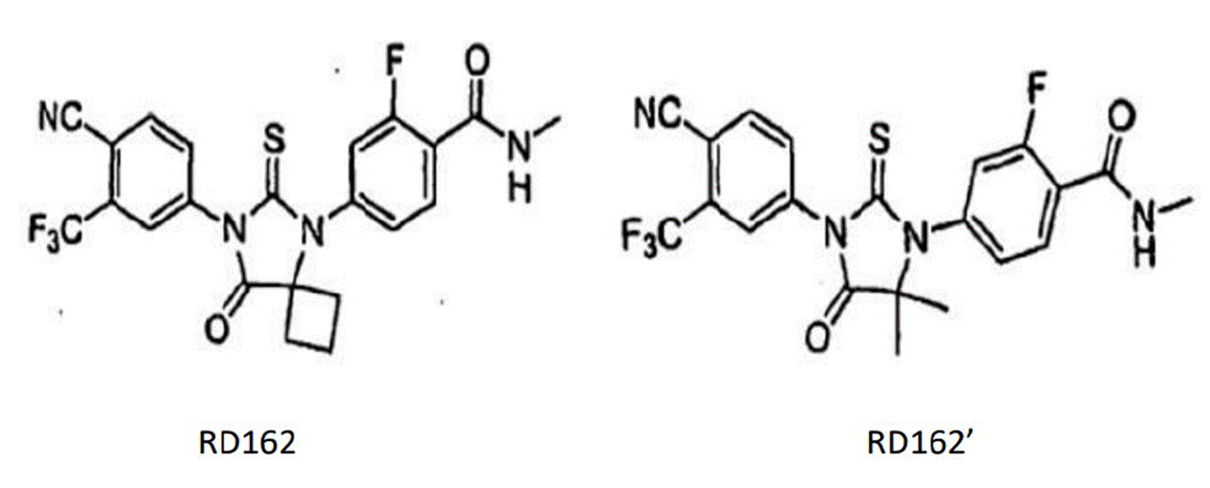

1. The only difference between RD162 and RD162' is in the substituent at the bottom right of the central thiohydantoin ring at what the judge called position X: RD162 has a cyclobutyl group and RD162' has a geminal dimethyl substituent (i.e. two methyl groups on the same carbon atom).

The skilled team

1. It is common ground that the Patent is addressed to a skilled team interested in seeking to develop a new drug for the treatment of prostate cancer, and in particular a new antagonist to the androgen receptor.  The team would include a person with knowledge and skills in the relevant biology of prostate cancer (“the cancer biologist”) and a person with knowledge and skills in medicinal chemistry (“the medicinal chemist”). The cancer biologist would understand the underlying disease and biological target, and use that understanding to develop a hypothesis for how the disease may be treated. The cancer biologist would select and/or devise suitable *in vitro* and *in vivo*testing. The medicinal chemist would be well-versed in drug design, synthesis, optimisation, purification and characterisation. The medicinal chemist would interpret *in vitro*and *in vivo*data for any novel therapy candidates that may be created during the research process and evaluate a compound’s physicochemical properties, pharmacokinetics and wider drug properties. That work might be done in conjunction with the cancer biologist.

The expert witnesses

1. The Claimants called Professor Ian Hickson (cancer biologist) and Professor Andrew Westwell (medicinal chemist). Astellas called Professor Noel Clarke (cancer biologist) and Professor Simon Ward (medicinal chemist). The only witness whose evidence was criticised was Prof Ward. The judge considered that some of the Claimants’ criticisms of Prof Ward were justified.

Common general knowledge

1. The judge set out the common general knowledge of the skilled team at [29]-[145]. Rather than setting it out all over again, I shall largely take this as read. In order to make this judgment intelligible, however, it is necessary to explain a few key points that would be known respectively to the cancer biologist and the medicinal chemist (with some overlap between them).

*The cancer biologist*

1. The prostate is an androgen-dependent gland and requires androgens for normal function. Androgens are steroid hormones. The predominant and most active androgens in men are testosterone and its metabolite 5α-dihydrotestosterone (“DHT”). Androgens bind to a protein called the androgen receptor (“AR”). The AR is a steroid hormone receptor and is found in many of the body’s tissues. The AR functions as a ligand-inducible transcription factor, which means that, upon binding of a ligand (such as testosterone or DHT), the AR modulates the expression of certain genes. When testosterone or DHT bind to the AR, they agonise (i.e. activate) the receptor and thereby initiate a cascade of processes that contribute to the survival, growth, and proliferation of normal and cancerous prostate cells.
2. Prostate-specific antigen (“PSA”) is a protein that is made predominantly in the luminal epithelial cells of the prostate gland, and is a well-known prostate tumour marker used in clinical practice for prostate cancer detection and the monitoring of treatment.
3. For treatment purposes, prostate cancer can be broadly categorised as clinically localised or metastatic, and as hormone-sensitive (i.e. androgen dependent) or hormone-resistant (i.e. cancer that has progressed despite initial androgen deprivation therapy (“ADT”)).
4. ADT is intended to reduce the quantity of androgens available to bind to the AR, or antagonise the action of androgens in the body, slowing the spread of the disease. One approach to ADT is to use molecules that compete with androgens for binding with the AR and thus inhibit activation of the AR. Instead of agonising the AR, the molecules would prevent binding of the circulating androgen to the AR, thereby preventing its activation. This is referred to as AR antagonism. These types of molecules are known as antiandrogens or AR antagonists. By 2006 this class included the non-steroidal antiandrogens flutamide, bicalutamide and nilutamide. Bicalutamide was commonly regarded as the “standard of care” treatment.
5. The available anti-androgenic therapies were widely used and clinically useful agents, but they did not prevent prostate cancer progressing from the hormone sensitive to the hormone refractory state. Moreover, they were ineffective in treating HRPC as the drugs lost their anti-androgenic activity and could become agonists, stimulating further progression of the disease rather than inducing its regression.
6. At the outset of a drug discovery project, the skilled team would typically have in mind an intended approach to treating the disease of interest. This would usually be led by the cancer biologist, who would provide the concept of how the disease would be targeted i.e. what biological pathway would be sought to be targeted, and which proteins or receptors or other biological features need to be modulated in order to achieve that biological effect.
7. With the intended biological target in mind, the skilled team would identify a target product profile (“TPP”) for their prospective therapeutic compound. This is a description of the properties of the compound which the skilled team would be seeking to identify. These would typically include physicochemical properties (e.g. appropriate molecular weight and lipophilicity), biological properties (e.g. activity against the target and minimal off-target effects), pharmacokinetic and pharmacodynamic properties (e.g. appropriate half-life), and drug-like qualities (e.g. not toxic at therapeutic doses). The TPP would typically be framed in a discussion between the cancer biologist and the medicinal chemist.
8. Compounds synthesised by the medicinal chemist would be tested for biological activity by the cancer biologist. A number of *in vitro*and *in vivo*assays were used to assess a compound for its potential effect on prostate cancer. With each assay, it is common to compare the test compound against a drug with a known behaviour, for example bicalutamide. *In vitro* assays include assays using cell lines (cells of a certain type which are maintained in culture).
9. A commonly used cell line in prostate cancer research in 2006 was LNCaP(Lymph Node Carcinoma of the Prostate). LNCaP cells express an endogenous level of functional AR and are androgen sensitive (so they can be stimulated by the presence of androgen or alternatively their function can be inhibited by an anti-androgenic agent). LNCaP cells also express PSA. Owing to those properties the cell line was used commonly in laboratory testing as a model of hormone sensitive prostate cancer. The effect of a putative antagonist or agonist in this hormone sensitive model could be assessed, for example, by measuring the PSA level produced by the cell line with the test compound present versus the PSA level produced by the cell line against a suitable control (for example, without the test compound being present or in the presence of an anti-androgen such as bicalutamide).
10. Half maximal inhibitory concentration (“IC50”) is a measure of potency, and is a quantitative measure that indicates how much of a particular inhibitory substance is needed to inhibit the activity of the target in a given biological process by 50%. IC50 values are typically expressed as molar concentrations. The IC50 of a drug can be determined by constructing a dose-response curve and examining the effect of different concentrations of an antagonist on inhibiting activity. IC50 values are used to compare the potency of two or more antagonists in development, or against an approved drug. A numerically lower IC50 value indicates a higher potency.

*The medicinal chemist*

1. With the TPP in mind, the medicinal chemist would seek to identify a compound or collection of compounds, which are a starting point for improvement. Once a suitable starting point is identified, the medicinal chemist would most likely adopt an iterative approach to modify the starting molecular structure to try to improve its activity, selectivity and/or physicochemical properties, bearing in mind the TPP. Iterative modification of a compound is done by developing a molecule that has a structure partially similar to the starting compound but with some different chemical substituents or modifications (i.e. a structural analogue). In order to progress the drug design process, the medicinal chemist often builds up a structure-activity relationship (“SAR”) library of such compounds and their test data.
2. To do this, the medicinal chemist would ordinarily make a series of chemical modifications to the starting compound, resulting in a number of different structural analogues. The medicinal chemist is trained in methods of adding functional groups to compounds, converting functional groups, and carrying out coupling reactions. These analogues would be tested to determine how each of the modifications affects their properties, including activity against the target, selectivity (by measuring activity against non-targets), solubility, permeability, etc. Through this process, the medicinal chemist would build up an idea of which parts of the compounds and what types of substituent modifications impact the relevant properties (such as binding, efficacy, physicochemical properties, metabolism, etc.), and the size and nature of the effects.
3. The physicochemical properties of a compound include its solubility, permeability and lipophilicity (how hydrophobic it is). A measure of lipophilicity is log P, the logarithm of the partition coefficient between water and a lipophilic solvent. ADME is a framework of concepts commonly used to help guide drug optimisation. The components of ADME are Absorption, Distribution, Metabolism and Excretion. Pharmacokinetics (“PK”) refers to how the body affects a specific substance after administration. PK is important in the development of drugs as part of understanding whether they will be safe at the appropriate dose and maintain efficacy for the desired amount of time.

The Patent

1. The judge summarised the disclosure of the Patent at [385]-[405], and considered a dispute as to whether Figure 21 showed that RD162' was more effective than RD162 at [406]-[418], but for the purposes of the appeal it is sufficient to note that Claim 1 is to RD162' or a pharmaceutically acceptable salt thereof.

The Poster

1. The Poster is a poster by Samedy Ouk and others entitled “Development of Androgen Receptor Inhibitors for Hormone-refractory Prostate Cancer” presented at the Prostate Cancer Foundation Scientific Retreat at Scottsdale, Arizona on 29 September to 1 October 2005 (“the Retreat”). The Poster (also referred to in the evidence as “Ouk”) is shown below.

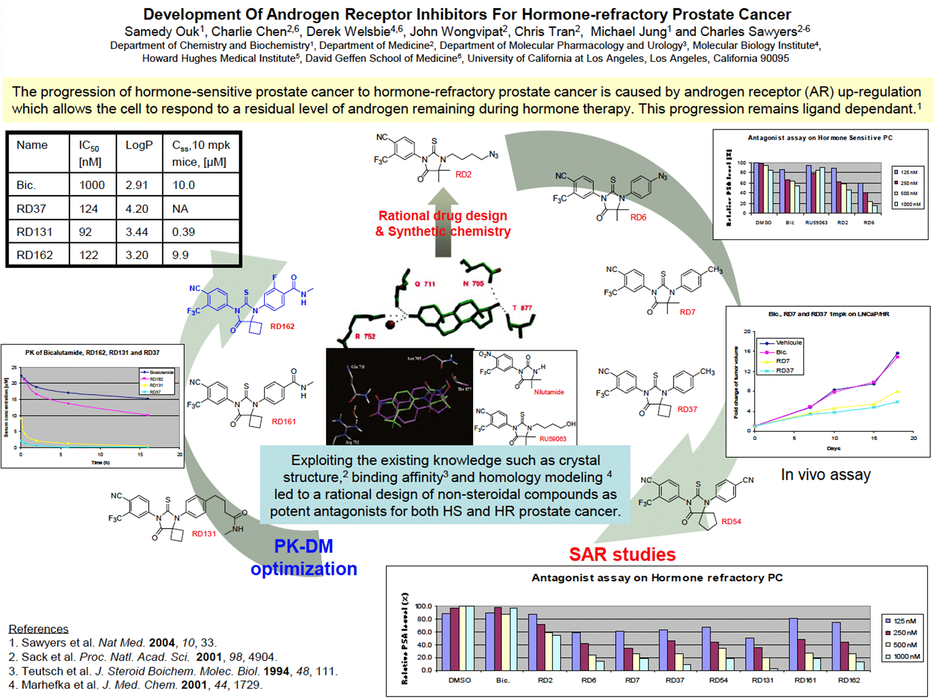

1. The judge set out what the Poster would disclose to the skilled team at [147]-[176]. This may be summarised as follows.
2. Under the heading is a yellow box explaining that AR upregulation is responsible for the progression of hormone-sensitive to hormone-refractory prostate cancer. This was one of the known explanations for why this progression occurred. In the central blue box, it is explained that “Exploiting the existing knowledge such as crystal structure, binding affinity and homology modelling led to a rational design of non-steroidal compounds as potent antagonists for both HS [i.e. hormone-sensitive] and HR [i.e. hormone-refractory] prostate cancer”.
3. The Poster depicts a step-wise process of development undertaken by the authors. Starting from the two prior compounds shown in the white box in the middle, nilutamide (a well-known antiandrogen used at the time in the treatment of prostate cancer) and RU59063, they engaged in “Rational drug design & synthetic chemistry” to make the compound RD2 shown at the top. They then proceeded as shown schematically by the arrows. There were two stages in the process. First, “SAR studies” were undertaken. The most potent compound in these studies was RD37. Secondly, “PK-DM [i.e. pharmacokinetics-drug metabolism] optimisation” was performed to arrive at RD162. The medicinal chemist can see from the numbers used for the compounds that not all are depicted and would understand that many more are likely to have been made and tested.

*SAR studies*

1. The medicinal chemist would understand that in these studies the authors were seeking to optimise the structure by making rational modifications in a step-wise fashion to investigate the impact on activity in the relevant prostate cancer models. The first compound is RD2, which the skilled medicinal chemist would note had structural similarities to nilutamide and in particular to RU59063 (the only difference being the change from a hydroxy group (OH) to an azide group (N3) on the right-hand side of the molecule).
2. The authors then move to RD6, where they have introduced a phenyl group on the nitrogen. RD6 still contains the azide group, but it now sits on the phenyl ring, rather than the alkyl chain in RD2. The next molecule is RD7, where the azide group has been replaced with a methyl group (of similar size to an azide, but less reactive and which is also lipophilic). The difference between RD7 and RD37 is at position X, with a dimethyl replaced with a cyclobutyl group.  This can be characterised as a small chemical change with the introduction of an additional CH2 group to make a ring.
3. The final compound in this section is RD54, which has two differences over RD37:

i)         First, the authors have further expanded the size of the bottom ring (at position X) to a cyclopentyl. The medicinal chemist would understand the authors had made these modifications in RD37 and RD54 to investigate the impact of different sized groups in the binding pocket.  It is apparent that the dimethyl, cyclobutyl and cyclopentyl groups at this position are all consistent with antagonist activity.

ii)        Secondly, the methyl group on the phenyl ring (on the right) has been replaced by a cyano group (CN).

*PK-DM optimisation*

1. This features three compounds, RD131, RD161 and RD162. In RD131 the left-hand side and centre are the same as in RD37 (including the cyclobutyl group at position X). The authors have started to modify the right-hand ring and have introduced new substituents at the 4-position, specifically an N-methylbutyramide group (i.e. a methyl amide linked to the phenyl group via a propyl chain).
2. In RD161 the methylamide group is directly attached to the phenyl ring. The medicinal chemist would appreciate that this would make the compound more rigid.
3. In RD162 (shown in a different colour to the other compounds) the authors have added a fluorine on the phenyl ring. The medicinal chemist would consider this had likely been done to improve metabolic stability compared to RD161 (although the PK data for RD161 are not shown), since they would know that the phenyl ring might be susceptible to oxidation, a precursor to elimination of the drug metabolite and a measure of instability. Adding a fluorine was a common approach to preventing metabolic oxidation.

*The cell-based data*

1. The chart at the top right shows data from an antagonist assay on HS prostate cancer, and the chart at the bottom shows data from an antagonist assay on HR prostate cancer. These would both be understood to be cell-based assays, which are measuring relative PSA levels and assessing the dose response of each of the compounds. PSA expression is being used as a surrogate for cell growth. A lower value for the relative PSA level indicates higher antagonist activity.

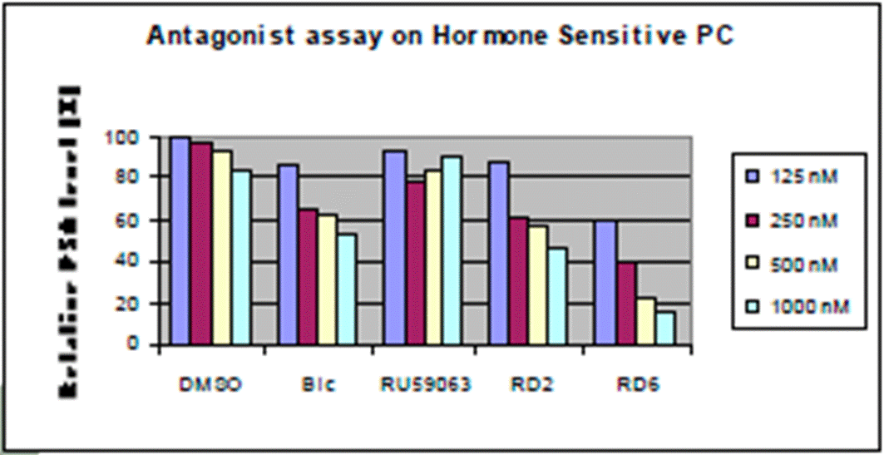

1. The HS assay data (reproduced above) shows bicalutamide (“Bic”) reducing relative PSA level in a dose-dependent manner i.e. it is behaving as an antagonist as expected in HSPC. It also shows a dose response for both RD2 and RD6, with at least RD6 performing better than bicalutamide.

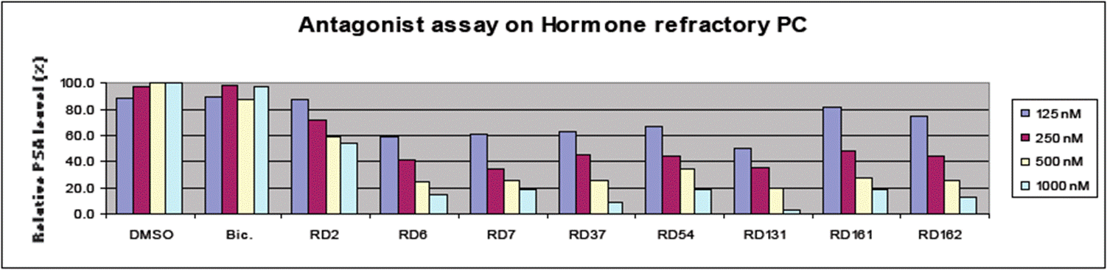

1. The HR assay data (reproduced above) shows that bicalutamide is not reducing PSA levels, indicating that it is not behaving as an antagonist in HRPC. However, all the RD compounds show much improved antagonist profiles and more significant reduction of PSA levels (particularly from RD6 onwards).

*The* in vivo *data*

1. In the centre on the right of the Poster is data from an *in vivo*assay which measures change in tumour volume over time following administration of bicalutamide, RD7 and RD37 over a number of days. A smaller increase in tumour size over the same period would be understood to show higher activity of a compound. It would be understood that the experiment probably involved implantation of cells from this human cell line into an animal (immunocompromised mouse) model in order to measure tumour growth *in vivo*.

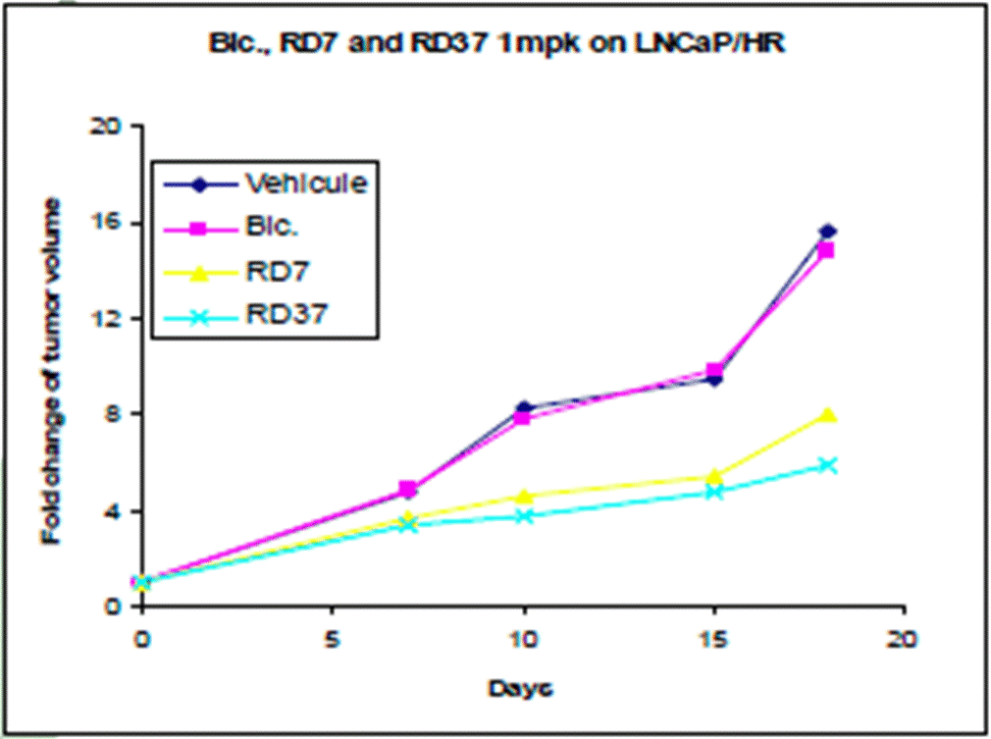

1. The data show that bicalutamide does not have an effect on HR tumour growth compared to the vehicle. In contrast, RD7 and RD37 have a discernible impact, both slowing tumour growth at a similar rate. RD37 (pale blue line) appears to perform better than RD7 (yellow line), but there is nothing to indicate whether this difference is statistically significant.

*The PK data*

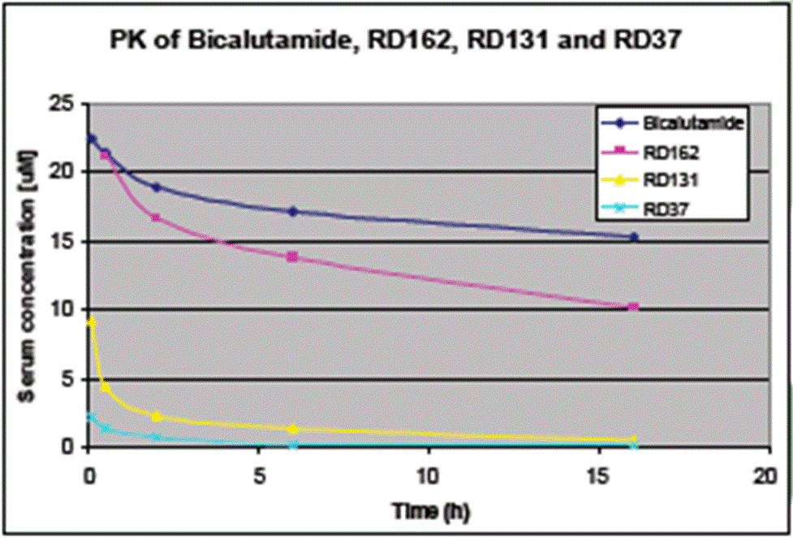

1. The chart in the middle of the left-hand side (reproduced above) shows that the serum concentration of RD37 and RD131 drops off very quickly after administration, whereas RD162 takes longer to clear and has a profile closer to that of bicalutamide. It is common ground that the PK profiles for RD131 and RD37 would be off-putting for once daily oral dosing, whereas that of RD162 is significantly better.

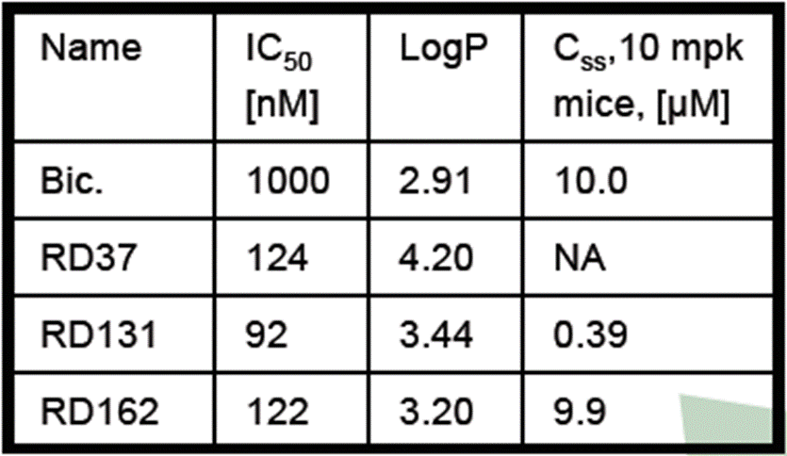

1. The table at the top of the left-hand side of the Poster (reproduced above) compares the IC50, LogP and Css (steady-state concentration) of RD37, RD131 and RD162. The following is common ground:

i)          Compared to bicalutamide, all three RD compounds are more potent antagonists (shown by their lower IC50 values).

ii)         The IC50 values for the three RD compounds are approximately the same.

iii)        Of the three RD compounds, RD37 is the most lipophilic (highest LogP), whilst RD162 is the least lipophilic (lowest LogP). Of the three RD compounds, the LogP value of RD162 is the most credible for a drug candidate.

iv)        RD162 has a significantly better steady-state concentration than RD37 and RD131 and is comparable to bicalutamide, which is consistent with the data in the PK chart.

The Slides

1. The Slides are slides from a presentation given by Charles Sawyers at the Retreat. The judge described what the Slides would disclose to the skilled team at [346]-[365], much of which is reproduced below.
2. The skilled team would understand from the Slides that the authors were investigating compounds for use in the treatment of HRPC. They would further understand from the Slides that it was important for such compounds to be AR antagonists and not to act as agonists.
3. Slides 5-7 describe the general approach of the authors in seeking compounds that were stronger antagonists of AR than bicalutamide, but without showing agonist activity in cells that overexpressed AR.
4. Slide 8 is a summary of “Design, Synthesis and SAR studies” that the authors have carried out. This is agreed to be a key slide. It explains that certain design tools were used to initially arrive at the compound shown as RU59063. This has high AR binding affinity but agonistic activity. Prof Westwell described the structure of RU59063 by reference to the circled parts shown in the figure below.

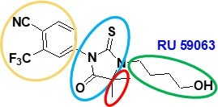

1. The yellow ring shows a 6-membered aromatic ring (phenyl) with two substituents: a cyano (CN); and a trifluoromethyl (CF3) group. The medicinal chemist would note that the same disubstituted phenyl ring is present in bicalutamide. The blue ring shows a heterocyclic five-membered ring with sulphur and oxygen substituents, known as a thiohydantoin. The green ring shows a hydroxybutyl (C4H8OH) group bound to one of the nitrogen atoms of the thiohydantoin ring. The red ring shows two methyl groups (a geminal dimethyl group) at the bottom of the structure bound to a carbon atom of the thiohydantoin ring.
2. Slide 8 also shows a pharmacophore (reproduced below). A pharmacophore provides an overview of the authors’ views of different interactions of a molecule within a binding site (in this case, the interactions of the molecules under study within the AR binding site). The targets for investigation are marked R, R1 and R2.

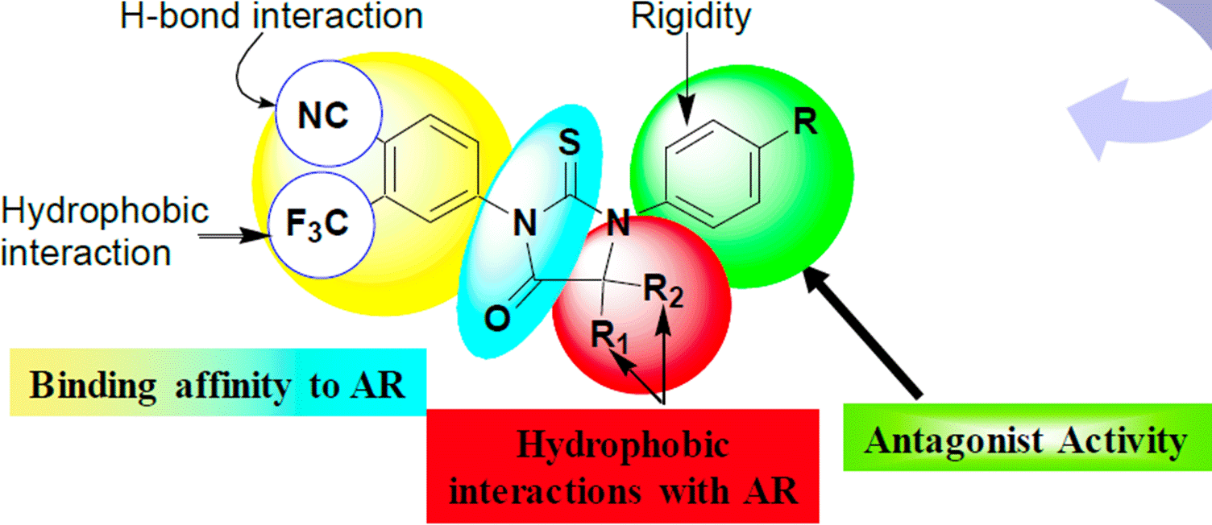

1. The medicinal chemist would note the following about this figure:

i)         The left-hand side (LHS) of the pharmacophore indicates that the cyano group (NC) at the 4 position of the LHS phenyl ring is important for hydrogen bond interaction and that the trifluoromethyl group (F3C) at the 3 position of the LHS phenyl ring is important for hydrophobic interaction. The LHS of the pharmacophore is structurally the same as the LHS substituted phenyl rings of both RU59063 and bicalutamide.

ii)        The LHS phenyl ring (shaded yellow) and part of the middle thiohydantoin ring (shaded turquoise) are indicated as being important for binding affinity to the AR. This part of the thiohydantoin ring is structurally the same as the thiohydantoin ring of RU59063. Bicalutamide does not have a thiohydantoin ring.

iii)        The left-hand side of the structure (in yellow and blue) are indicated as important to binding affinity to the AR and shown as fixed (i.e. no change).

iv)        The remaining part of the middle thiohydantoin ring (shaded red) is indicated as being important for hydrophobic interactions with the AR. The geminal dimethyl group (red) is generalised from RU59063 by the use of two further placeholder groups, shown by R1 and R2.

v)         The right-hand side (RHS) (shaded green) is another phenyl ring and is said to provide “antagonist activity”, with the phenyl ring also providing “rigidity”. The medicinal chemist would understand that rigidity is obtained because a phenyl ring is a flat and rigid group that can only rotate on its axis. This contrasts to RU59063 (which is said to have agonistic activity) which did not have rigidity in this position, as its flexible alkyl chain can take on lots of different configurations. The experts agreed that the medicinal chemist would therefore understand that the key development in this structure over RU59063 is the introduction of the “right” (green) phenyl group, with this moiety seemingly resulting in the molecule having the desired antagonistic activity without agonistic activity.

1. Slide 9 shows the structure of RD37 and describes it as a potent antagonist in hormone sensitive LNCaP cells. Data is presented that shows RD37 reducing relative PSA levels in a dose-dependent manner compared to bicalutamide and RU59063. RD37 exemplifies the pharmacophore of slide 8 in that:

i)          In place of R1 and R2at the C5 position of the middle thiohydantoin ring is a cyclobutyl (a four-membered carbon ring).

ii)         In place of R at the 4 position of the RHS phenyl ring is a methyl group (CH3).

1. Slides 10-15 present further data relating to RD37, setting out its benefits, including that it acts as an AR antagonist in HRPC cell lines without agonist activity (slides 10, 11), that it shows selectivity for AR (slide 12), that it has comparable binding affinity to bicalutamide (slide 13), and that it slows the growth of HRPC cell line *in vivo* compared to bicalutamide. Slide 15 provides some PK and PD data on RD37, showing that it has a short serum half-life and is cleared after around 6 hours.
2. Slide 16 presents the structures of two derivatives of RD37: RD131 and RD162. It also presents PK data relating to these compounds and also bicalutamide. This is materially the same as the data that is shown in the Poster (see paragraph 39 above), the only difference is that the text below the chart on slide 16 makes it clear that the serum concentrations were measured after IV dosing, whereas this is not stated in the Poster. This slide shows that RD37 has PK problems, with high logP values (too lipophilic) and its PK after dosing is poor (almost all gone after 15 hours). No steady state value can be given.
3. The box on slide 16 indicates that the inventors had then tried a number of different compounds (the structures of RD131 and RD162 being shown) with RD162 having good IC50 values, reasonable LogP and good steady state concentration, when compared to bicalutamide. Of the three molecules disclosed on this slide, RD162 performs by far the best in PK after IV dosing, where it shows promising performance as compared to bicalutamide.
4. Slide 17 shows how RD37, RD131 and RD162 perform in a cell-based assay mimicking HRPC, measuring relative PSA levels. RD37, RD131 and RD162 all show an antagonist-type dose response with increasing concentrations.
5. Slide 18 states the following conclusions:

“Cell-based screens can be used to identify anti-androgens with greater potency than bicalumatide [sic] while avoiding the undesirable agonism side-effect

SAR has defined a thiohydantoin imine derivative of the high affinity ligand RU59063 as an attractive lead

Greater potency can be achieved in the absence of greater binding affinity, presumably through inducing altered AR conformation

Further in vivo studies are in progress to define an optimal clinical candidate”

1. The experts were agreed that the first three conclusions summarise the key points from the preceding slides (even though the reference to “imine” would not be understood).
2. The experts were also agreed that the “Further *in vivo* studies” were in progress to optimise the PK properties of RD162, since there is no doubt that the most promising candidate identified in the Slides is RD162. In other words, the lead compound from the Slides (taking into account both activity and PK data) is RD162.
3. RD162 shares the structure of RD37 with different substitutions being made to the right-hand phenyl ring (a methylamide group directly attached to the ring with an added fluorine on that phenyl ring). As with the other compound depicted in the Slides (namely, RD131), RD162 retains the cyclobutyl on the central ring, a feature of RD37.

Obviousness: applicable principles

1. The judge discussed the law at [177]-[226]. There is no dispute as to the accuracy of that account. For the purposes of the appeal it is sufficient to note the following points, most of which are drawn from the judgment of Lord Hodge in *Actavis Group PTC EHF v ICOS Corp* [2019] UKSC 15, [2019] Bus LR 1318.
2. As Lord Hodge noted at [60], it is common for English courts to adopt the structured approach to the assessment of obviousness described by Jacob LJ in *Pozzoli SPA v BDMO SA* [2007] EWCA Civ 588, [2007] FSR 37 at [23] (“the *Pozzoli* approach”):

“(1)  (a) Identify the notional ‘person skilled in the art’; (b) Identify the relevant common general knowledge of that person;

(2)  Identify the inventive concept of the claim in question or if that cannot readily be done, construe it;

(3)  Identify what, if any, differences exist between the matter cited as forming part of the ‘state of the art’ and the inventive concept of the claim or the claim as construed;

(4)  Viewed without any knowledge of the alleged invention as claimed, do those differences constitute steps which would have been obvious to the person skilled in the art or do they require any degree of invention?”

1. At [63] Lord Hodge said:

“In *Conor Medsystems Inc v Angiotech Pharmaceuticals Inc* [2008] 4 All ER 621, para 42, Lord Hoffmann endorsed the fact-specific approach which Kitchin J set out in *Generics (UK) Ltd v H Lundbeck* [2007] RPC 32, para 72 where he stated:

‘The question of obviousness must be considered on the facts of each case. The court must consider the weight to be attached to any particular factor in the light of all the relevant circumstances. These may include such matters as the motive to find a solution to the problem the patent addresses, the number and extent of the possible avenues of research, the effort involved in pursuing them and the expectation of success.’

Kitchin J’s list of factors is illustrative and not exhaustive. Another factor which needs to be considered in the present case is the routineness of the research. …”

1. Lord Hodge went on to consider nine factors which are often relevant considerations. Two of these are particularly pertinent for present purposes:

“69.  Fifthly, the existence of alternative or multiple paths of research will often be an indicator that the invention contained in the claim or claims was not obvious. If the notional skilled person is faced with only one avenue of research, a “one-way street”, it is more likely that the result of his or her research is obvious than if he or she were faced with a multiplicity of different avenues. But it is necessary to bear in mind the possibility that more than one avenue of research may be obvious. In *Brugger v Medic-Aid Ltd (No 2) [1996] RPC 635* , 661, Laddie J stated:

‘if a particular route is an obvious one to take or try, it is not rendered any less obvious from a technical point of view merely because there are a number, and perhaps a large number, of other obvious routes as well.’

I agree. As a result, the need to make value judgements on how to proceed in the course of a research programme is not necessarily a pointer against obviousness.

70.  Sixthly, the motive of the skilled person is a relevant consideration. The notional skilled person is not assumed to undertake technical trials for the sake of doing so but rather because he or she has some end in mind. It is not sufficient that a skilled person could undertake a particular trial; one may wish to ask whether in the circumstances he or she would be motivated to do so. The absence of a motive to take the allegedly inventive step makes an argument of obviousness more difficult. …”

1. Motivation to take a particular step is not a necessary condition for a finding of obviousness, however. In *Pharmacia Corp v Merck & Co Inc* [2001] EWCA Civ 1610, [2002] RPC 41 Aldous LJ said:

“123.  Mr Kitchin realised that this Court was unlikely to reverse the decision of the judge, on what has been called a jury question, unless he could show that the judge had gone wrong in principle. He submitted that he had done just that. First, he submitted that the judge had failed to realise that to find the invention obvious, it was necessary to conclude that there was some obvious reason or purpose to make the compounds of claim 1. In support he referred us to this passage in the judgment of Laddie J. in *Hoechst Celanese Corp. v. BP Chemicals Ltd* [1997] F.S.R. 547 at page 573:

‘Before a step from the prior art can be held to be obvious there must be some reason why the man skilled in the art would wish to take it. If he has a problem and the step would occur to him as a solution to it, then he has a reason. But there is no requirement that it be demonstrated that the step would have been expected to produce significant commercial advantages. The problem might be very small. The courts will assume that he may just want an alternative way of achieving essentially the same result as in the prior art. Thus mere workshop modifications, none of which would be expected to produce significant technical or commercial benefits are still obvious. To adopt an example sometimes given by Jacob J., if it is known to make a 5-inch plate, it is obvious to make a 5¼-inch plate. Technicians and businessmen frequently want to make trivial variations in established or known products. Similarly if the prior art discloses two wooden parts held together by screws it would be obvious to glue them, even if so doing would not be expected to advance the industry. The notional addressee is likely to want to use materials readily at hand to make essentially the same thing as is disclosed in the prior art. That is sufficient motivation and the use of those materials is, accordingly, obvious. When the defendants argue that Hingorani or any of his readers is entitled to use any “natural extension” or “obvious variant” of his concept, they are correct if by that they mean the type of workshop modification or alternative discussed above. But it was not and could not be suggested by any witness that changing the medium from aqueous to organic and changing the resin was a mere workshop variant of what is set out in Hingorani.’

124.  That statement of the law was, I expect, apt on the facts of that case, but should not be followed generally. A step from the prior art, albeit made without reason, can still be obvious. The judge categorises such a step as workshop modifications and, in so doing, introduces a test not in the statute, namely whether the step from the prior art was a workshop modification. The statutory test is obviousness and any modification which is obvious will not be patentable, whereas one which is not obvious will be. The true test … is to ask whether the invention was obvious. Whether or not there is a reason for taking the step from the prior art may well be an important consideration, but that does not mean that it is an essential requirement of a conclusion of obviousness. In any case, the judge in these proceedings did consider whether there was a reason for taking the step from the prior art and concluded that there was, namely a natural desire to investigate the analog[ue]s and the structural activity relationship of such compounds. ….”

Obviousness: the test on appeal

1. Since the assessment of obviousness involves a multi-factorial evaluation by the judge, this Court is only entitled to intervene if the judge erred in law or principle: see *Actavis v ICOS* at [78]-[81]. As the Supreme Court emphasised in *Lifestyle Equities CV v Amazon UK Services Ltd* [2024] UKSC 8, [2024] Bus LR 532 at [46]-[50] (Lord Briggs and Lord Kitchin), and has recently re-emphasised in *Iconix Luxembourg Holdings SARL v Dream Pairs Europe Inc* [2025] UKSC 25 at [94]-[95] (Lord Briggs and Lord Stephens), it is not enough that this Court might have reached a different conclusion.

Obviousness over the Poster

*The Claimants’ case*

1. The Claimants’ primary case of obviousness over the Poster before the judge, and the only case pursued on appeal, was set out in Prof Westwell’s first report at paragraphs 9.42-9.60. He started at 9.42 by stating:

“I have been asked to consider what would have been obvious to the skilled team in the light of Ouk at the Filing Date and in particular whether, without knowledge of the Patent, the inventions set out in certain claims of the Patent would have been obvious. I have in mind the importance of not contaminating my analysis with hindsight and that for the purpose of this exercise I should put out of my mind the knowledge I have from having read the Patent as part my involvement in this case, and the knowledge I acquired after the Filing Date in my own research relating to enzalutamide.”

1. He explained at 9.43 that he had been asked to follow the *Pozzoli* approach. At 9.46 he noted that the difference between claim 1 and the disclosure of the Poster “is that the compound of claim 1 (RD162’) has a dimethyl substituent at the bottom right position of the central ring whereas the RD162 compound of Ouk has a cyclobutyl substituent at that position”*.* He went on:

“9.47 For the following reasons, I do not believe that it would require any degree of invention for the skilled medicinal chemist who had read Ouk to make a modification to RD162 so as to make a compound where the cyclobutyl substituent was replaced by a dimethyl substituent.

9.48 The skilled medicinal chemist presented with Ouk would recognise that RD162 is being presented as a compound with therapeutic potential to treat prostate cancer which shows *in vitro* activity, and also has acceptable pharmacokinetic properties.

9.49 From the disclosure in Ouk the skilled medicinal chemist would expect certain variants of RD162 to have the same or similar activity and therefore also have therapeutic potential. In particular, the skilled medicinal chemist knows from the teaching in Ouk that the cyclobutyl at the bottom right position can be substituted with a dimethyl or a cyclopentyl (as shown in RD7 and RD54) without having a significant impact on *in vitro* activity.

9.50 Ouk shows that the most significant development in achieving *in vivo* serum stability (at a comparable level to SOC bicalutamide) is the installation of a 3-fluoro substituent in the aryl ring joined to the central thiohydantoin, which the skilled medicinal chemist would understand to be a common method to prevent liver-based cytochrome P450 metabolism for orally administered drugs, as discussed. Therefore, although predicting the site of metabolic oxidation is often difficult based on chemical structures alone, the skilled medicinal chemist would understand that the aryl ring joined to the central thiohydantoin was the likely site of metabolic oxidation because RD162 (which includes the 3-fluoro substituent in the aryl ring) is shown to be stable. There is no reason to consider that a change from the cyclobutyl group to either a dimethyl or cyclopentyl would affect metabolic stability. This is because these are small changes which retain the same hydrocarbon functionality and are made at a site that is remote from the metabolic site. Additionally, the routine incorporation or removal of a single CH2 group to this hydrophobic part of the molecule (going from dimethyl to cyclobutyl or vice versa) would not significantly affect properties such as logP, and consequently would not change properties such as solubility or *in vivo* biodistribution, in any significant way.

9.51 It would therefore be immediately obvious to the skilled team that the following two compounds would be likely to have therapeutic potential that was similar to that of RD162.

”



1. Prof Westwell added:

“9.53 I have been asked to consider whether changes to other parts of RD162 would also result in molecules which would be expected to have similar therapeutic potential. Other changes could be investigated but the activity of such molecules prior to testing would be more uncertain and therefore their therapeutic potential as compared to RD162 would not be as immediately obvious, in particular because of the potential for disadvantageous PK-DM properties compared to RD162.

9.54 For example, based on the information in Ouk, the skilled medicinal chemist would not be confident that changes could be made to the left-hand side of RD162 (shown below) because that part of the structure has been kept fixed all the way from RU59063. It would therefore be uncertain, based on Ouk, as to whether changes to that part of the molecule are consistent with activity.

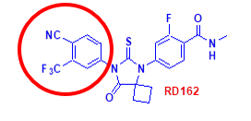

9.55 The skilled medicinal chemist would also understand that making modifications to the top right ring (shown below) could result in different properties. For example, it has been shown in Ouk that the addition of a N-methylbutamide group at the 4-position with a longer chain (as shown in RD131) does not have desirable PK properties (specifically in relation to its short half-life and resulting inability to achieve a useful steady state concentration). Furthermore, the methyl group in the same position on RD37 results in a compound with a higher LogP and potential issues with drug solubility and steady state concentration.

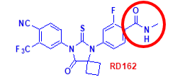

9.56 As I have said above the skilled medicinal chemist will understand that the inclusion of the fluorine atom was likely to improve metabolic stability. The skilled medicinal chemist would therefore retain a fluorine at this position. There is the possibility of moving from the fluorine atom from the 3-position to the 2-position (which is equivalent to the 5-position) but the effect of this would be uncertain. Whilst fluorine atoms are commonly used to resolve issues of metabolic stability, their effect is unpredictable and moving the position of the fluorine atom may have a negative impact.

”

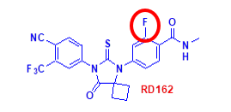

*The judge’s assessment*

1. The judge quoted paragraphs 9.49-9.51 and 9.53 of Prof Westwell’s first report in [233] and [235] and summarised 9.54-9.56 in [236].
2. At [237] the judge set out three reasons advanced by Astellas as supporting a finding that RD162' was inventive. Each was based on the evidence of Prof Ward. The judge rejected each of these reasons at [238]-[276].
3. At [278] the judge said:

“As far as I could detect, no challenge was made to the technical reasoning which Prof Westwell put forward in support of obviousness over the Poster. Instead, Astellas accused Prof Westwell of approaching the Pozzoli analysis incorrectly. They drew attention to 9.46-9.47 (and 10.28-10.29, which I consider later) of his first report and an answer he gave in cross-examination.”

1. At [280]-[304] the judge considered the Claimants’ secondary case that it would be routine to conduct an SAR study starting from RD162 and that would lead the medicinal chemist to RD162'. Although this case is no longer pursued, it is necessary to note some statements made by the judge in this context.
2. At [285] the judge cited a passage from the cross-examination of Prof Westwell concerning the Slides. Since this is quite a long passage I will not set it all out, but I should quote the last few questions and answers:

“Q. I think you said you did not because you were asked to assess obviousness in terms of -- I am assuming what you were going to say is in terms of the difference and assessing the difference between a gem-dimethyl and a cyclobutyl?

A. Mmm-hmm.

Q. And with that change in mind, you were then saying well, is that going to have an effect or not or make any obvious changes? That is what you were doing really, is it not?

A. Yes, assessing the obviousness of that change in light of the material presented in the public conference, yes.

Q. That is right. So when you say the obviousness of that change, what you were thinking was ‘If I am asked about the change between cyclobutyl and gem-dimethyl, do I think that change is an obvious one to make in light of what I have here?’

A. Yes.”

1. The judge went on:

“286. Later, when asked about his evidence as to what was obvious over the Poster, Prof Westwell confirmed that he had approached that issue in the same way as he had on the Slides and came to the same conclusion.

287. Three important points emerge from that passage:

i)   First, that when challenged, Prof Westwell did not say that his reasoning was part of a SAR.

ii)   Second, that Prof Westwell regarded the obvious steps he had talked about in his reports as distinct from a SAR.

iii)   Third, that he was asked to assess obviousness in terms of the difference between a gem-dimethyl and a cyclobutyl. However, I keep in mind that when Prof Westwell said this, he might well have been referring to Pozzoli step 3 (identify the differences). As I have already mentioned, he set out the Pozzoli approach in [9.42] of his first report and there are clear signs in his written evidence that he was endeavouring to follow that approach.

288. Astellas submitted a fourth important point also emerged from the final question and answer: that in that answer Prof Westwell effectively admitted that he had the target (i.e. RD162’ i.e. with the dimethyl group) in mind when concluding the step from RD162 was obvious. However, I do not consider that was clearly established. There is a subtle difference between having the target clearly in mind and considering whether it was obvious to make a change at position X from the cyclobutyl group to a dimethyl group. The basis of Prof Westwell’s penultimate answer was ‘in light of the material presented in the public conference’ (which would not have included RD162’). That was echoed in the final question.”

1. The judge explained at [289]-[291] that Astellas had nevertheless submitted that it was clear from his written reports that Prof Westwell’s analysis was infected with hindsight. At the start of a drug discovery project the medicinal chemist and the cancer biologist would agree a TPP. In cross-examination, Prof Westwell agreed that what the medicinal chemist would do would be conditioned on the TPP to be discussed with the cancer biologist. The SAR would progress to identify a front runner molecule, whereupon modifications are likely to become more focussed on improving that front runner. Despite this, when it came to the question of obviousness, there had been no mention of a TPP either by Prof Hickson or Prof Westwell. Furthermore, in his written evidence Prof Westwell had not expressly mentioned conducting a SAR exercise.
2. The judge went on:

“292. So, the problem with Prof Westwell’s evidence on obviousness is the absence of a proper description of the context in which his Skilled Team formed the view that it was ‘immediately obvious’ (from the Poster) that the two RD162 analogues he depicted at [9.51] would be likely to have therapeutic potential that was similar to that of RD162.

293. It could be said that the Professor was presented with an unusual situation, in that the Poster presented a molecule RD162 with all the attributes of a lead molecule, so there was no need for a TPP or a SAR to be conducted. Yet Prof Westwell never said as much. Equally, Prof Westwell did not say that the Skilled Team would embark on an exercise of seeking to characterise RD162 by making analogues …. He did explain why the Skilled Medicinal Chemist would have been either reluctant or uncertain about making modifications to the other parts of the molecule, apparently leaving only position X to be considered.

294. Furthermore, the absence of a SAR or other context could be said to be emphasised by the fact that in [9.53]-[9.56] he considered whether changes to other parts of RD162 would result in molecules expected to have similar therapeutic potential, but apparently only because he was asked to do so i.e. that consideration did not arise because of a particular scenario or context that his Skilled Team was considering.

295. At this point it is necessary to consider the sequence in which Prof Westwell was introduced to the various documents in the case. It is clear that the sequence was: consideration of the CGK of the Skilled Medicinal Chemist; what the Skilled Medicinal Chemist would understand from the Slides; then he was shown the Patent and asked to explain what the Skilled Medicinal Chemist would understand from its contents. He explained that many months later he was provided with a copy of the Poster and was asked to describe what the Skilled Medicinal Chemist would understand from its contents, having been told to put out of his mind what he had previously discussed with the solicitors.

…

297. Despite the sequence, it is curious that Prof Westwell’s report was structured so that he presented his views on obviousness over the Poster first (with the ‘immediately obvious’ wording). When it came to obviousness over the Slides, he did not use that expression and his reasoning was tied much more closely to material in the Slides, as I discuss below.”

1. At [305]-[319] the judge considered a third case which the Claimants had advanced in cross-examination of Prof Ward, namely that it would be obvious to carry out an SAR study starting from RD7 and that would lead the medicinal chemist to RD162'. Counsel for the Claimants showed us that this case was disavowed in closing submissions. Nevertheless, it is again necessary to note some statements made by the judge in this context.
2. The judge said at [306] that the problem with this line of argument was that there was no reason to want to progress RD7. As the judge explained at [308], the compound in the Poster with the best activity in the SAR studies was RD37, which was then optimised to RD162:

“… But the potential for further optimisation on the right-hand side of the molecule is clear in order further to improve PK and drug like properties.  Why go back to a discarded compound with ostensibly *less*activity?”

1. Having considered the evidence of the experts about the data in the Poster, the judge said at [311]:

“Overall, the experts agreed that whilst RD37 looks slightly ahead in the tumour volume study, it is difficult to draw conclusions, but RD37 and RD131 are both better than RD7 in the HR prostate cancer PSA level assay - something that the biologists agreed would be of real interest.”

1. After noting that the Poster did not permit statistical conclusions to be drawn, the judge went on:

“314. Although no statistical analysis has been done, as Astellas submitted, the clear take home message of the Poster is that RD37 had better activity than RD7 which was why it was RD37 that went through to *in vivo* PK testing and it was why it is the scaffold structure of RD37 which was then shown being changed with the different right-hand side substituents.

315. Notwithstanding the above, the case was put to Prof Ward on an assumption that a Skilled Medicinal Chemist reading the Poster would think all of the compounds after RD6 were essentially the same or the same. The assumption was something of a moving feast: …

316. I agree that all of this was untethered to reality. A Skilled Team reading the Poster as a whole would understand that the message being conveyed is that the most active compounds were RD37 and RD131 and work had then been done to improve their ‘drug like’ properties leading to RD162.”

1. At [321]-[332] the judge considered three points of secondary evidence relied upon by one side or the other, none of which he considered persuasive.
2. At [333]-[345] the judge set out his conclusion. The core of his reasoning was in the following passage:

“336. This case involves a somewhat unusual situation, in that what was published, in the Poster was a molecule RD162 which showed good efficacy and good PK-DM properties. It was clear that the Skilled Team would regard RD162 as a good candidate to take forward into further testing. The motivation to consider other molecules came from competitive and patenting considerations, in the sense that it would be prudent for the Skilled Team to view RD162 as ‘belonging’ to the authors, it being a reasonable assumption on the part of the Skilled Team that the authors/their employers would have already applied for patent protection, and therefore the Skilled Team needed to develop their own molecule, novel and different from RD162.

337. This case raises, in an acute form, the issue as to the extent to which competitive and patenting considerations should influence an obviousness analysis. As usual, the answer is provided by consideration of what real-life teams would do. Although some expert witnesses do have experience of patenting considerations, many do not, so the Court can be left to rely on its own experience.

338. I can start with the case as originally presented in Prof Westwell’s first report. There are a number of problems with this case, including the following:

i) Prof Westwell does not explain the scenario in which the Skilled Team decides to take the step which he says is obvious. In particular he does not explain why the Skilled Team starts by considering position X, nor why the Skilled Team starts to consider changing the cyclobutyl group at that position.

ii) His answers in cross-examination indicate that he was not considering the situation where the Skilled Team had decided to do a SAR or characterise RD162 in order to find out information which would help to decide how to proceed. Instead, his answers indicated he was asked to consider the change from cyclobutyl to dimethyl and asked whether that change would have a material effect. Even if I assume in his favour that he was referring to Pozzoli step 3, the invitation put to him was leading.

iii) In this regard, there is no separate body of law which is applicable if the change required to get from the prior art to the claim is said to be ‘immaterial’ or ‘trivial’. In every case, there is only one question and it is the statutory question of ‘is it obvious?’. Whether a change is properly characterised as ‘immaterial’ or ‘trivial’ is highly fact dependent and there is a real danger (as has been pointed out in some of the authorities) that the question of immateriality is substituted for that of obviousness, even though a conclusion that a change is immaterial or trivial will usually be determinative of the question of obviousness. In general terms, I agree with Astellas’ submission that these issues of ‘immateriality’ or ‘triviality’ are not well suited to the field of medicinal chemistry, but it all depends on the context.

iv) The quest for a novel compound would have taken the Skilled Medicinal Chemist away from close analogues to RD162. The focus on close analogues was driven by the hindsight knowledge that the Patent in fact claims RD162’. Without that knowledge, on this primary case the Skilled Medicinal Chemist would not have been motivated to investigate close analogues of RD162. I have to consider this point further in the alternative ‘obvious to do a SAR’ case.

v) Overall, I am driven to the conclusion that Prof Westwell’s evidence that the change from cyclobutyl to dimethyl was ‘immediately obvious’ was tainted with hindsight.”

*The appeal*

1. The Claimants’ starting point is that (i) the judge was correct to note at [278] that no challenge was made to the technical reasoning which Prof Westwell put forward in support of obviousness over the Poster and (ii) each of the three reasons for non-obviousness advanced by Astellas, based on the evidence of Prof Ward, was rejected by the judge. In those circumstances, the Claimants submit, the irresistible conclusion is that the invention claimed in the Patent was obvious in the light of the Poster.
2. The Claimants contend that, in reaching the opposite conclusion, the judge erred in principle in two ways. First, they argue that the judge erred in looking for a “context” or “scenario” for what was technically obvious. The skilled person or team is deemed to be interested in alternative ways of achieving essentially the same result as that obtained by the prior art and this, of itself, provided sufficient context.
3. Secondly, the Claimants argue that the judgment contains an internal inconsistency in that the judge rejected an allegation that Prof Westwell’s cross-examination showed that he had approached the question of obviousness over the Poster with hindsight at [287 (iii)] and [288], but later in the judgment at [338(i)-(v)] he held in relation to the same cross-examination that *Pozzoli* step 3 was leading and that Prof Westwell’s conclusion was tainted with hindsight.
4. So far as the first argument is concerned, the Claimants emphasise that, as discussed above, motivation to take a particular step is not a necessary condition for a finding of obviousness. It is possible for a patent to be found obvious because a step is technically obvious even if the skilled person has no motive to take it because the existing solution produces a perfectly acceptable result: see, for example, *Research in Motion UK Ltd v Visto Corp* [2008] EWHC 335 (Pat), where Floyd J stated at [73] that the court “will readily assume that technicians and businessmen will wish to make trivial changes to what is known in order to produce essentially the same result.”
5. As I read the judgment, the judge did not question this. The point he made in [338](iii) is that whether a change is properly characterised as “trivial” is highly fact-dependent, and there is a real danger that the question of “triviality” is substituted for that of obviousness. In general, he agreed with Astellas that the issue of “triviality” is not well suited to the field of medicinal chemistry, but it all depended on the context. As he had explained at [198], the fact that a modification to a compound is “small” in structural terms does not necessarily mean that it will obviously have no material effect.
6. Nor do I understand the judge to have questioned the legitimacy of approaching the issue of obviousness on the footing that the skilled team, having read the Poster, would be interested in developing an antagonist for HS and HR prostate cancer that was simply an alternative to RD162.
7. The point that the judge made at [292] and [338](ii) was a different one: in assessing Prof Westwell’s evidence, it was significant that Prof Westwell had not said that he was approaching the issue on the premise that the skilled team, having read the Poster, would be interested in developing an antagonist for HSPC and HRPC that was simply an alternative to RD162. Indeed, Prof Westwell did not explain what objective the medicinal chemist would have in mind at all. This is what the judge meant by the absence of “context” or “scenario”.
8. Counsel for the Claimants’ first response to this was to point out that Prof Westwell had stated in 9.49 that the medicinal chemist “would expect certain variants of RD162 to have *the same or similar activity and therefore also have therapeutic potential*” and in 9.51 that it would be “immediately obvious … that the following two compounds would be likely to have *therapeutic potential that was similar to that of RD162*” (emphases added). Thus, he argued, Prof Westwell was considering what obvious alternatives to RD162 would be expected to have similar activity. The difficulty for the Claimants is that these paragraphs form part of Prof Westwell’s reasoning for the conclusion he expressed in 9.47. They are not a substitute for an articulation by Prof Westwell of the premise upon which he considered the question of obviousness. The judge was entitled to take that omission into account when assessing Prof Westwell’s evidence.
9. As counsel for Astellas submitted, if Prof Westwell had approached the issue in that way, one would have expected him to consider (among other things) the question identified by the judge in the context of the “take forward RD7” case at [308]: starting from RD162, why would the medicinal chemist go back from a cyclobutyl group to geminal dimethyl groups at position X when comparison between RD7 and RD37 indicates that RD37 (with a cyclobutyl group) is more active than RD7 (with geminal dimethyl groups)? At the very least, one would expect this question to be discussed between the medicinal chemist and the cancer biologist, but Prof Westwell says nothing about any such discussion. He does not say, for example, that he has been informed by Prof Hickson that the cancer biologist would regard the activity of RD7 as acceptable even though it is less than that of RD37. Instead, Prof Westwell’s focus in 9.50 was upon the effect of changes at position X on PK-DM issues, which would be within the remit of the medicinal chemist.
10. Counsel for the Claimants argued that the judge was not entitled to make the finding he made in [311], [314] and [316] that RD37 had better activity than RD7, particularly in the HRPC PSA level assay, since it was based on an incorrect recollection of the evidence of Prof Hickson. This is not a ground of appeal for which the Claimants have permission. Furthermore, it is a challenge to a finding of fact as to how the results reported in the Poster would be interpreted by the skilled team, and therefore can only succeed if that finding was rationally insupportable. The judge considered the evidence of both Prof Clarke and Prof Hickson on this topic in [310], and he understood them to have been agreed. Thus the finding was not based solely on the evidence of Prof Hickson, and it was certainly not insupportable.
11. Counsel for the Claimants also argued that, even if the judge’s finding was correct, it was plain that the activity of RD7 was acceptable because the data in the Poster showed that it was materially better than bicalutamide, which was the standard of care. Indeed, as the judge noted at [169], “all the RD compounds show much improved antagonist profiles and more significant reduction of PSA levels”. For a skilled team seeking an alternative to RD162, the key criterion would be better activity than bicalutamide, and it would not matter if the alternative was (say) 15% less active than RD162 if it was materially better than bicalutamide. While I see the force of this argument, the fact remains that no such approach was articulated by Prof Westwell in his report.
12. Counsel for the Claimants’ second response to the point identified in paragraph 85 above was to argue that it was common ground between Prof Westwell and Prof Ward that the medicinal chemist would consider obvious alternatives to RD162 that they would expect from reading the Poster to retain the desired biological activity. For this purpose counsel for the Claimants relied upon certain passages in Prof Ward’s reports in which Prof Ward said, for example, that the Poster “gives the Skilled Chemist a portion of the compound (the RHS substitutions) that they can vary and seek to modify, while retaining a degree of confidence that the desired biological activity will be preserved”. Again, however, this argument misses the point, which is that this approach was not expressed by Prof Westwell in his first report.
13. Turning to the second error of principle which the Claimants contend that the judge made, I see no inconsistency in the judge’s reasoning. In [287](iii) and [288] the judge was addressing Astellas’ submission that the passage of cross-examination the judge quoted in [285] demonstrated that Prof Westwell’s reasoning was tainted with hindsight, in particular because he had had the target (RD162') clearly in mind. The judge did not accept that submission.
14. At [289]-[297] the judge considered a different submission by Astellas, namely that it was nevertheless clear from his reports that Prof Westwell’s approach was infected with hindsight. The judge did not give his answer to that submission in this passage, but he did note (i) the absence of context discussed above, (ii) the sequence in which Prof Westwell had considered the documents and (iii) the way in which Prof Westwell’s first report was structured.
15. The judge expressed his conclusion in [338](iv) and (v): Prof Westwell’s evidence was tainted with hindsight, because the skilled team looking for a novel compound (i.e. an alternative to RD162) would not have been motivated to consider close analogues of RD162. The focus on close analogues was driven by the hindsight knowledge that the Patent claims RD162'.
16. Counsel for the Claimants argued that this conclusion was predicated upon the judge’s finding in [338](ii) that “the invitation put to [Prof Westwell] was leading”, which was inconsistent with [288]. I disagree. As the judge said in [288], there is “a subtle difference between having the target [i.e. RD162'] clearly in mind and considering whether it was obvious to make a change at position X [of RD162] from the cyclobutyl group to a dimethyl group”. The judge was not persuaded that it was established that Prof Westwell had had the target clearly in mind. The judge went on in [338](ii) to find that Prof Westwell “was asked to consider the change from cyclobutyl to dimethyl and *asked* whether that change would have a material effect”, which was leading.
17. Counsel for the Claimants also argued that this criticism was unjustified for two further reasons. First, the cross-examination was about the Slides, not the Poster, and the judge stated at [379] that Prof Westwell’s approach to the Slides “was less clearly redolent of hindsight”. Secondly, Prof Westwell had been instructed by the Claimants to adopt the *Pozzoli* approach, which he had faithfully followed, and that could not be condemned as leading.
18. I do not accept these arguments. So far as the first point is concerned, counsel for Astellas submitted that the relevant part of the cross-examination concerned both the Slides and the Poster, but the passage which the judge quoted focussed on the Slides. That does not avail the Claimants because, as the judge noted at [286], Prof Westwell confirmed that he had adopted the same approach in relation to the Poster. Moreover, as the judge noted at [295], Prof Westwell formed his opinion in relation to the Slides before being asked to consider the Poster. Thus hindsight was inevitably more of an issue with respect to the Poster than with respect to the Slides. As the judge remarked, it is odd that Prof Westwell’s report was structured the other way round.
19. As for the second point, I do not understand the judge to have criticised the Claimants for instructing Prof Westwell to adopt the *Pozzoli* approach or Prof Westwell for doing his best to follow it. The judge’s concern was that Prof Westwell was nevertheless led to focus on changing cyclobutyl to dimethyl at position X (rather than making other modifications to RD162) and whether that would have a material effect, rather than considering what would be an obvious way forward from RD162. In other words, as with many quizzes, there was a clue to the answer in the phrasing of the question, or at least in the way the witness understood the question. Even with the best intentions, it is difficult for an expert witness to avoid hindsight, particularly when that expert has already considered a closely-related item of prior art.
20. I would nevertheless comment that, in my opinion, explicitly instructing an expert to follow the *Pozzoli* approach can create a risk of hindsight. The court normally adopts the *Pozzoli* approach, but it does not follow that it is necessary to instruct the expert to do so. In the present case, for example, there was no room for dispute as to what the difference between RD162 and RD162' was in structural terms (step 3 in *Pozzoli*). Hindsight would have been easier to avoid if Prof Westwell had been asked an open question along the following lines: supposing that the skilled team, after having read the Poster, wanted to develop an alternative to RD162 which had similar therapeutic potential, what compound(s) would have been obvious choices to investigate? In saying this, I am not intending to be prescriptive about how experts should be instructed, particularly in other kinds of case.
21. In conclusion, I consider that the judge was entitled to conclude that Prof Westwell’s evidence was infected with hindsight. He certainly made no error of principle in doing so.

Obviousness over the Slides

*The Claimants’ case*

1. The essential difference between the Slides and the Poster, for present purposes, is that in the Slides there is no side-by-side testing of compounds containing geminal dimethyl groups on the one hand and a cyclobutyl group on the other hand. Instead, information is provided to the skilled team by the pharmacophore.
2. Again, the Claimants rely upon the evidence of Prof Westwell in his first report:

“10.29 For the following reasons, I do not believe that it would require any degree of invention for the skilled medicinal chemist who had read the Slides to make a modification to RD162 so as to make a compound where the cyclobutyl substituent was replaced by a dimethyl substituent.

10.30 As I have stated, the skilled medicinal chemist would recognise RD162 to be the most promising compound disclosed in the Slides. It is the only compound identified as having antagonistic activity *in vitro* combined with useful pharmacokinetic properties (Slide 16). The skilled team would, according to the pharmacophore, expect certain variants to have the same or similar activity and therapeutic potential.

10.31 In terms of understanding the different parts of the molecule and their importance with respect to the performance, the skilled medicinal chemist would consult the pharmacophore from Slide 8. This explains that the left-hand side of the structure is responsible for binding affinity to AR and therefore the skilled medicinal chemist would expect that modifications here would have the potential to have a significant impact on activity.”

10.32 It also confirms that the rigid structure on the right-hand side of the molecule is required for antagonistic activity. Although certain changes to this part of the molecule are consistent with antagonistic activity *in vitro* (compare RD37, RD131 and RD162) it is only the inclusion of the methylamide substitution on the phenyl ring in combination with the fluorine substitution which gives rise to acceptable pharmacokinetic properties. The skilled medicinal chemist would not know whether such properties could be retained if that part of the molecule is altered.

10.33 According to the pharmacophore in Slide 8 the cyclobutyl group in RD162 is designated R1/R2. The skilled medicinal chemist is informed that this part of the molecule is involved in hydrophobic interactions. The skilled medicinal chemist would want to keep R1 and R2 the same in order to avoid introducing an unwarranted chiral centre, which I have explained in the CGK section. It would be obvious that each of R1 and R2 could be methyl as these would be expected to behave similarly to the cyclobutyl group in RD162 being only slightly smaller. They are also present in RU59063. The expectation would be that substituting two methyl groups for the cyclobutyl would not materially impact pharmacokinetic properties because they are both simple hydrocarbon groups. It follows that if RD162 is seen (as it would be) as having therapeutic potential it would be obvious to the skilled team on the basis of the data disclosed that a molecule in which the cyclobutyl group has been replaced with dimethyl will be likely to have similar therapeutic potential. This would be obvious on the data disclosed in the Slides.”

*The judge’s assessment*

1. Having noted at [370] that in 10.29 Prof Westwell had used the same wording, *mutatis mutandis*, as in 9.47, the judge quoted 10.30-10.33 at [371]. At [372] the judge commented that Prof Westwell’s reasoning was “closely tied to material in the Slides”. At [374] the judge noted that “the technical reasons [Prof Westwell] gave were not challenged”. At [375] the judge recorded that Astellas’ challenge was that Prof Westwell’s evidence was driven by hindsight. At [377] the judge set out four arguments advanced by Astellas as to why it would not have been obvious for the skilled team, having read the Slides, to investigate dimethyl at position X.
2. The judge expressed his conclusion as follows:

“379. The obviousness arguments in this case were finely balanced, the more so in relation to the Slides. I have changed my mind on obviousness over the Slides more than once because Prof Westwell’s technical reasons were cogent and because his approach (which I infer was formulated before he saw the Poster) was less clearly redolent of hindsight.

380. The problem, once again, was that he did not explain the context in which his Skilled Team would make the considerations set out in his technical reasoning.

381. In their cross-examination of Prof Ward, the Claimants strove to provide a context - the SAR starting from RD162 - in which they suggested the Skilled Team would have made and tested RD162’, as a byproduct of their characterisation of RD162. However, my findings in relation to the ‘obvious to do a SAR’ in the context of the Poster apply equally here.

382. … there was a degree of exaggeration in the second, third and fourth points made by Astellas. After that exaggeration is stripped out, there remained some force in the underlying points. With those points in mind, the Skilled Team would be likely to regard a suggested change from cyclobutyl to dimethyl as something of a backward step. The advantage of the characterisation argument was that it provided a reason to ignore the fact that that step might be a backward one.

383. In view of my reservations about certain parts of the evidence of Prof Ward, the characterisation argument came very close to succeeding but I have to bear in mind the following points:

i) First, that if the steps required to get from the prior art to the claim are obvious, it ought to be possible to explain that case clearly and in evidence in chief.

ii) Second, in the litigation process there is an intense focus and much analysis of the route(s) to obviousness and the obstacles in the way.

iii) Third, that it is hardly surprising that, with a skilful cross-examination driven by an intense focus on the target, an argument for obviousness may appear to have force.

384. Naturally, I am not saying that an obviousness argument cannot be proved through cross-examination of the patentee’s expert witness. However, in the circumstances of this case, I am unable to conclude that I received sufficient primary evidence to establish the allegation of obviousness over the Slides.”

*The appeal*

1. The Claimants again contend that the judge erred in principle in looking for “context” for what was technically obvious. The argument is the same as in the case of the Poster, and my answer is the same. The judge was entitled to take this omission by Prof Westwell into account, and he made no error of principle in doing so.

Conclusion

1. For the reasons given above I would dismiss the appeal.

**Lord Justice Snowden:**

1. I agree.

**Lord Justice Zacaroli:**

1. I also agree. As Arnold LJ has pointed out, a conclusion on obviousness is a highly fact-dependent evaluative decision where the judge who has been immersed in the detail of the case has a significant advantage over an appellate court. That is particularly so in a specialist area in which the judge is well-versed, and where the judge has heard the cross-examination of the technical experts. The judge’s findings that Professor Westwell’s conclusion was tainted with hindsight  and failed to identify the context for what was technically obvious are themselves fact-dependent aspects of that overall evaluative decision. I agree with Arnold LJ that the Claimants’ arguments on appeal do not reach the threshold for establishing that those findings involved an error of law or principle.